MIE 1622

Assignment 1

Ziyang Zeng

1001226577

1. Implement Investment Strategies

In this report, four investment strategies are to be tested: Buy and Hold, Equally Weighted, Minimum Variance, Maximum Sharpe Ratio. Each strategy is rebalancing a portfolio of 20 stocks bi-weekly for a total of 24 weeks. (12 periods)

Within the function of each individual investment strategy, a validation procedure(fig1.1) is included after the weights are optimized. First of all, to ensure that there will be enough budget to rebalance the portfolio, there has to be enough cash accumulated in the cash account to pay off the transaction costs. In other words, a procedure has to be implemented to sell more and buy less but keep the weights the same so that cash accumulated in the cash account will be more than the transaction costs. Then, the cash account will be positive.

The code, shown in fig1.1, is written inside the main script “portf_optim” after the strategy function is called. It first initializes a step size of one for cash deposited in the cash account. Then, it goes through a while loop and will not end until the cash account is positive after deducting transaction costs. The loop first checks if the cash account is positive, or in other words, is there enough budget to rebalance the portfolio. If not, the loop then calculates the amount of shares that needs to be adjusted to for each stock if certain amount of cash is accumulated, which is taken out of the portfolio. Then the cash remaining is calculated after the transaction costs and costs to buy additional stocks are deducted from the cash from last period plus the cash resulted from selling the stocks. If the cash account is still negative, then we add increments to accumulate more cash until the cash account is positive.

In addition, in order to let the shares to be integer numbers, the “round” function is implemented inside the while loop. It allows us to round to the nearest integer and ensure that the we are not running over the budget.

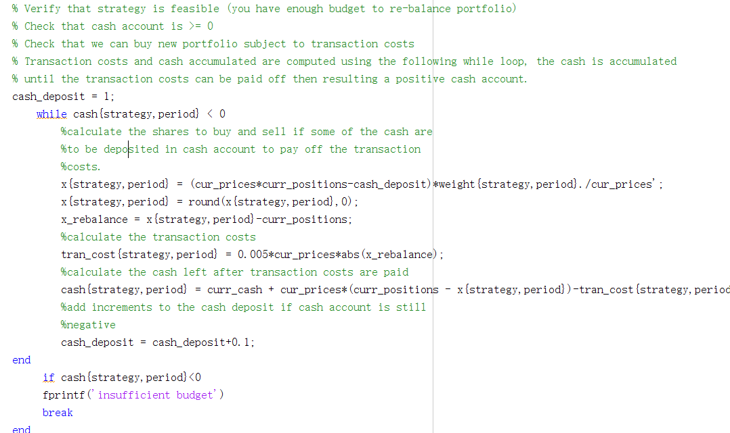

Fig1.1 Snippet of the code for validation to ensure enough budget to rebalance the portfolio.

1. Results analysis

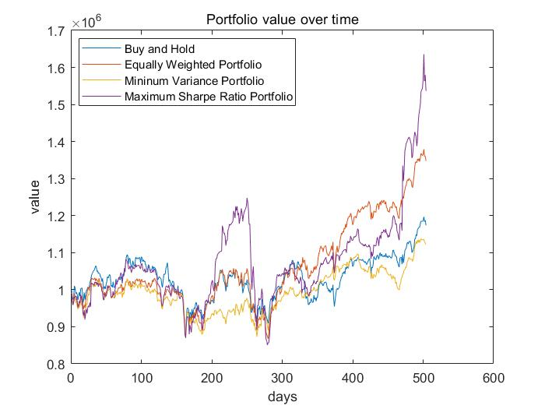

Fig2.1 Portfolio value over 504 days for four strategies implemented.

As shown in fig2.1, “Max Sharpe Ratio” and “Equally Weighted” strategy lead to relatively high return after the entire 12 periods, while “buy and hold” and “min variance” strategy lead to relatively low return. The “Max Sharpe Ratio” strategy gives the final portfolio value as high as $1536967.45 at the end of the period, but we can also see there is a very large spike near 200days to 300days region where it then suddenly drops down dramatically compared to the other 3 strategies. The “Min Variance” strategy underperforms the other three portfolios most of the time but on the other hand has the most steady shape and little fluctuations. The “Buy and Hold”strategy follows the trend of the “Max Sharpe Ratio” at the beginning until 200 days region. The “ Equally Weighted Strategy” gives a steady trend with moderate fluctuations and a relatively high return.

From the plot we can see that “Max Sharpe Ratio” strategy is sensitive to excess returns and drops in the market. The strategy can effectively capture the high return momentum which is obvious in 200 – 300 days region and 500days region. However, it is also sensitive to the large drops in the market. Overall, max sharpe ratio strategy is a good choice for investors aim for higher return but with a moderate level of risk tolerances. The” Min variance”strategy, in the opposite, capture less effectively for the high returns but minimizes the fluctuations, which is more suitable for risk averse investors.

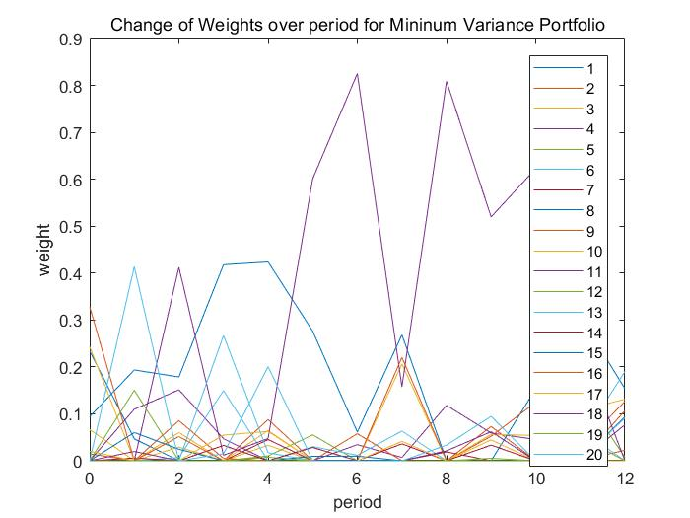

Fig 2.2 Min variance strategy dynamic change of weights

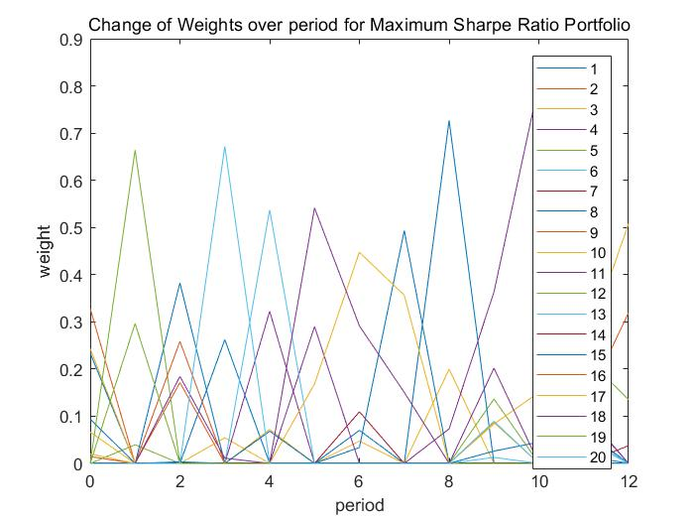

Fig 2.3 Max Sharpe Ratio strategy dynamic change of weights

The amount of weights change for rebalancing “Max Sharpe Ratio” is more than “Min variance”. This may lead to more potential transaction costs.

For me, as an investor, I would choose “Max Sharpe Ratio” as my investment strategy. Although there is a huge drop within 200 – 300 days region after the spike, the drop can be minimized through setting the stop loss limit, e.g 10%. Most of the time, the “Max Sharpe Ratio” outperformed the other three strategies when there are potential gains in the market, but it seldomly fall below the “Min Variance” and “Buy and Hold” strategy significantly. Therefore, if there is a disciplined stop loss setting combine with the “Max Sharpe Ratio” strategy, the loss could be minimized and the profits can be accumulated.

1. Possible improvements to the strategy

In this section, four different rebalancing frequencies are tested to verify if there are possible improvements on the choices of the rebalancing frequencies. The frequencies to be tested are, rebalancing once at the beginning and hold, rebalancing monthly, rebalancing every four months, rebalancing every six months.

It turns out that when rebalancing only once at the very beginning of the period 1 and hold until the end of the period 12, the “Min Variance” and “Equally Weighted” strategies are performing better than the other frequencies of choice, ending with a portfolio value of $1390133.07 and $1494056.02 respectively. The most profitable strategy is the “Max Sharpe Ratio” under 4 months frequency which ends with final portfolio value of $1904414.76 and dramatically outperforms the other strategies under any frequencies. The rationale behind this might be the fact that a four month frequency has reduced the transaction costs for the “Max Sharpe Ratio” strategy which requires significant change of weights that may lead to higher costs. On the other hand, a four month frequency is not too long to lose the opportunity to capture the momentum of the market to go up. Therefore, it is a good choice of rebalancing frequency for “Max Sharpe Ratio”.

Other possible suggestions on the improvements of the strategies include taking the transaction costs into account when optimizing the weights. In this assignment, transaction costs are not considered when optimizing weights and they are only considered when calculating portfolio value and to ensure that the cash account is positive. In addition, there can be a stop loss and gain limit implemented in the strategy to reduce fluctuations when the market drops down. Through avoiding losing money when the market drops, the profit can be accumulated throughout the entire period.

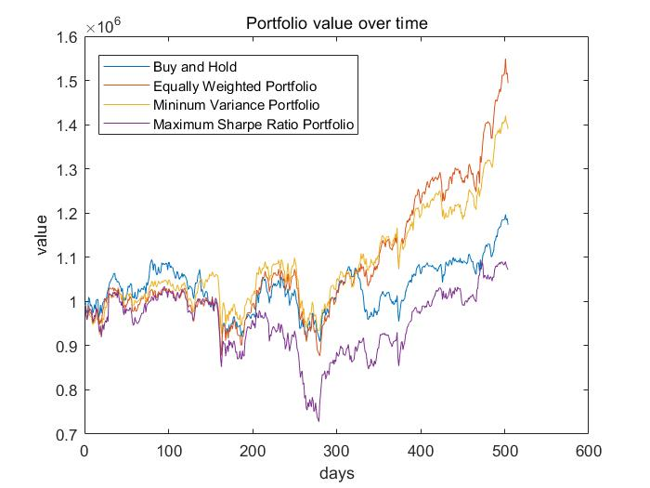

Fig 3.1 Rebalance the portfolio at the beginning of period one and hold it till the end of the period 12 for each of 4 strategies

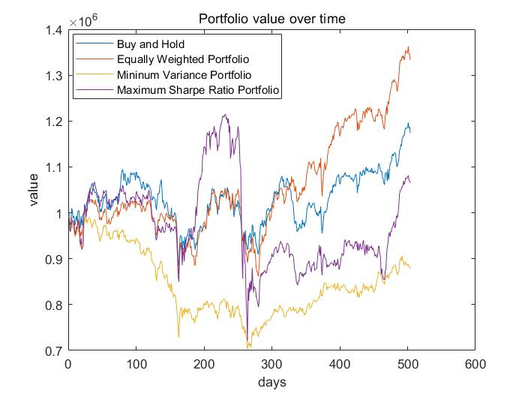

Fig 3.2 Rebalance the portfolio every month.

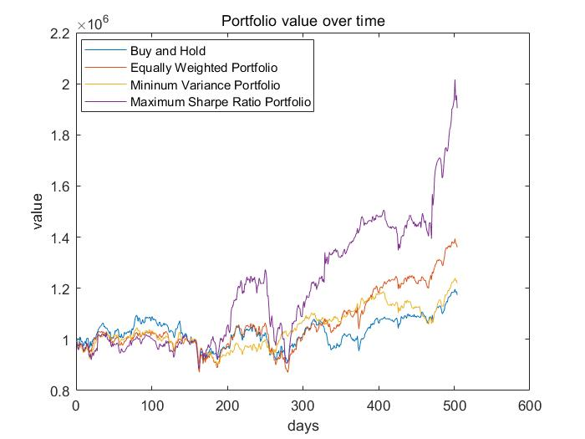

Fig 3.3. Rebalance the portfolio every 4 month

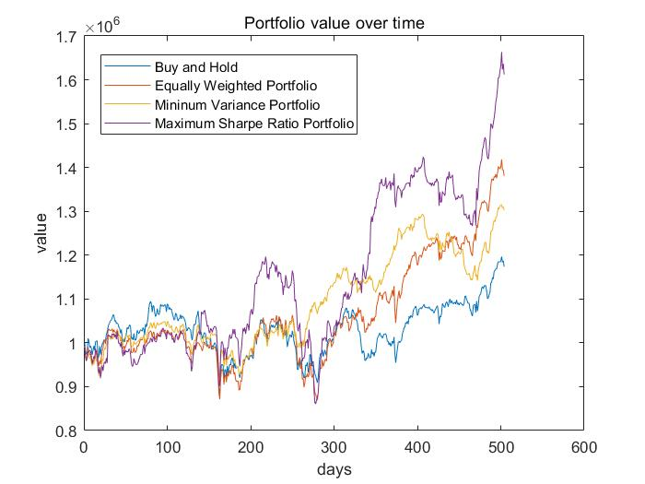

Fig 3.4 Rebalance the portfolio every 6 month

|  |  |  |  |  |  |
| --- | --- | --- | --- | --- | --- |
|  | Rebalance at the beginning and hold | Rebalance bi-monthly | Rebalance monthly | Rebalance  every 4 months | Rebalance every 6 months |
| Buy and Hold | 1173675.24 | 1173675.24 | 1173675.24 | 1173675.24 | 1173675.24 |
| Min Variance | **1390133.07** | 1122270.69 | 879057.07 | 1219409.34 | 1302821.09 |
| Equally Weighted | **1494056.02** | 1350187.55 | 1333199.22 | 1360719.22 | 1380765.68 |
| Max Sharpe Ratio | 1071676.33 | 1536967.45 | 1065542.50 | **1904414.76** | 1612231.44 |

Table 3.1 Final portfolio value for each strategy under different rebalancing frequencies.

**Appendix.**

Matlab Output for 12 period strategies.

